CEE 641
Fate and Transportation
Modeling of Ecosystem

Technical Report

Assessing Eutrophication potential of Snug Harbor following Bioremediation

Shibo Wang
sw5qc@virginia.edu

Nov.20,2007

Introduction and Purpose
The EXXON Valdez oil spill in March 1989 seriously contaminated the ecosystem of Prince William Sound, Alaska. Numerous wild lives suffered severe body damage and even death. It was raised by some scientists that the situation could be improved by bioremediation. Fertilizers were applied in the summer of 1989 to stimulate bacterial growth to clean up the beaches of Prince William Sound. However, the risk of eutrophication which was caused by the application of nutrients, including phosphorous and nitrogen increased. Therefore, the potential of excessive algal growth, i.e. eutrophication would be one of the biggest concerns. The relationship is shown in Fig.1 below. Based on this consideration and limited data, EPA model WASP/EUTRO, the most popular water quality modeling structure was utilized to evaluate the potential of eutrophication in Snug Harbor. This evaluation is divided into two general steps, that is, the calibration of mass transport and the eutrophication potential in Snug Harbor, which is based on the mass transport. The seasonal algal concentrations are simulated prior to fertilizer application. After that, a series of nutrients loads based on different fertilizers are developed to evaluate the impacts of bioremediation. The results of model simulation are intended to indicate the impacts of nutrients application rather than the actual prediction of the algal biomass in the Snug Harbor.
Eutrophication
Excessive
Algal Growth
Bacteria
Remediation
Exxon Oil Spill
Contamination
Nutrients
Fig.1. Relationship of bioremediation and eutrophication
The WASP model framework is based on the finite-segment approach. This unique approach converts the three-dimensional calculations to three one-dimensional calculations, significantly reducing the computational efforts. The fundamental rationale behind the modeling analysis is mass balance, i.e. the output amount of a specific conservative substance should be always equal to its input amount.
Simulation of phytoplankton growth in an estuarine system is complicated by several factors. Biological, biochemical, and chemical reaction processes interact with each other and the reaction rates vary with time. Also, the freshwater flow and mass transport patterns are functions of time. Therefore, time-variable phytoplankton modeling is computationally intensive, which requires substantial data to calibrate and verify. However, it is formidable in the reality. On the other hand, in many systems like Snug Harbor, phytoplankton growth is a seasonal event, which means that it is appropriate to approximate the phytoplankton-nutrients dynamics on a seasonal steady-state basis. According to the methodology developed by Lung and O’Connor (1984) and Lung (1986), the modeling simulation is basically based on the assumption that two-layer mass transport in Snug Harbor is under tidally averaged steady-state assessment. Written it in another way, V=aQ^{b}, when b=0, V=a, the velocity in the segments of Snug Harbor is constant, i.e. under tidally averaged steady state. Moreover, the flushing time for Snug Harbor is relatively short due to tidal actions.
In the modeling analysis of Snug Harbor, it is divided into four segments, which are showed in Fig. 2.
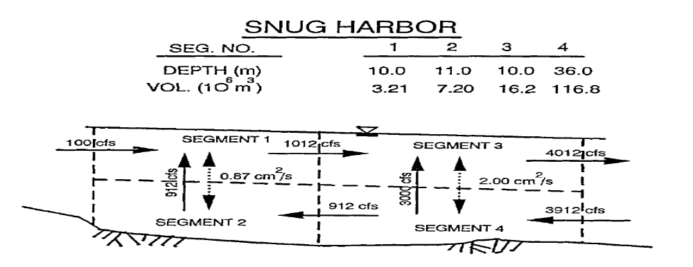
Fig.2 Two-layer mass transport in Snug Harbor (Lung, 1993)
Data Analysis
Since salinity is conservative, it is a good indicator of mass transport in the Snug Harbor. The measured salinity in the two sampling stations in Snug Harbor is showed in Fig.3.
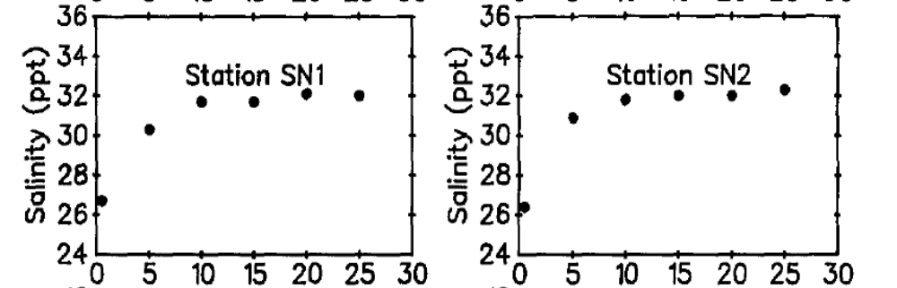
Fig.3. Measured salinity in Sung Harbor, on July 11, 1989 (Lung, 1993)
In Fig.3, it can be found out that in the surface layer (0-10m), the salinity increases sharply. In the depth below 10 m, the salinity keeps constant. Therefore, there is a salinity stratification effect in Snug Harbor. This indicates that it is incompletely mixing. And the reason why the top layer has the lowest salinity is because that the inflow of freshwater dilutes this area.
2-D Mass Transport Model
The WASP model structure is based on the finite-segment approach, i.e. the embayment under simulation is divided into several segments, and corresponding parameters are given to each segment. It requires that the objective water system is separated into a few completely mixed segments. The modeling framework can be used to calculate concentrations of conservative substances, such as salinity, chloride, specific conductivity, and total dissolved solids. Also, it can be used to model nonconservative substances which follow linear reaction kinetics. The key of conducting a WASP model simulation is correctly making input file under specified situation. The input file is formatted ASCII file. All the input data should be placed in the appropriate fields, and integers should be right justified. Eight groups of data (model options, exchanges, volumes, flows, boundary conditions, loadings, parameters, constants, time functions and initial conditions) need to be accurately configured. Based on the successful running of input file, four kinds of files (mass balance file-- *.msb, transport file-- *.trn, result file-- *.edf, output file-- *.out) should be generated. The WASP model is capable of simulating both time-variable and steady-state conditions.
In this case, the 2-D WASP model (horizontal and vertical) is used to assess the mass transport of Snug Harbor by considering steady-state condition. Shown in Fig.2, Snug Harbor is generally separated into 2 layers, 4 segments.
According to the essentials of mass balance and flow balance, the input and output of each segment and the 4 segments as a whole should be balanced. Knowing that 100 cfs coming into segment 1, 3912 cfs coming into segment 4, 4012 cfs flowing out of segment 3, 912 cfs coming through the border of segment 2 and 4, and 1012 cfs going through the border of segment 1 and 3, three advetive flows are derived, which are 100, 3000 and 912 cfs, respectively. The flow fields of each of them can be specified: 100-cfs flow goes through segment 1, 3, and goes into Prince William Sound; 3000-cfs flow first enters segment 4, rises to segment 3 and finally outputs into Prince William Sound; 912-cfs flow comes from the Prince William Sound, goes through segments 4, 2, 1 and 3, and infloods the Prince William Sound in the end. Among these three advective flows, 912 and 3000 cfs flows represent the tidally averaged situation. The flow balance is maintained in term of the three advective circulations. Tidally averaged longitudinal velocities can be first calculated based on the measured salinity data in Fig.3. Then, mass-transport attributes including vertical dispersion coefficient, advective and dispersive flows are determined. Brought forth by salinity gradient, the vertical dispersion coefficients between segments 1, 2 and segments 3, 4 are 0.87 and 2.00 cm²/s, correspondingly.
Model Results
The input file containing only NH₃ system is incorporated in the SAL5.EXE code. NH₃ is considered as salinity. Therefore, the nitrification rate is considered to be zero. 4 segments and 1 system are identified. Compare the calculated values of salinity with the measured ones in table.1. It can be found that the calculated values match measured values very well. Also, it indicates that the coefficients of mass transport are well-tuned. Besides, it is discovered that the salinity in segment 1 is less than that in segment 3, and that in segment 2 is smaller than that in segment 4. Similarly, the salinity in segments 1 and 3 are lower than those in segments 2 and 4, due to the upper layer freshwater inflow.
Table.1. Comparison of modeled and measured salinity in Snug Harbor
Segment # | 1 | 2 | 3 | 4
Calculated Salinity (ppt) | 31.4 | 34.4 | 34.1 | 34.9
Measured Salinity (ppt) | 29.75 (26.75-31.33) | 32.04 (32.00-32.32) | ---- | ----
Model Sensitivity Analyses
1. Vertical Dispersion Coefficient
The values of both vertical dispersion coefficients is modified from 0.87 and 2.0 cm²/s to 8.7 and 20.0 cm²/s (10 times), 87.0 and 200.0 cm²/s (100 times) respectively. The change of average salinity in each segment is shown below.
Table.2. vertical dispersion coefficient sensitivity
Segment # | 1 | 2 | 3 | 4
1 time salinity  Mg/L | 31.4 | 34.4 | 34.1 | 34.9
10 times salinity  Mg/L | 31.0 | 32.3 | 34.1 | 34.4
100 times salinity  Mg/L | 30.8 | 31.0 | 34.1 | 34.2
From table.2, it can be discovered that with the increment of vertical dispersion coefficient, the salinity in segment 1, 2 and 4 decreases slightly, and that in segment 3 keeps constant. Meanwhile, it can be found that with the rising vertical dispersion coefficient, the concentration difference between segment 1, 2 is bigger than that of segment 3, 4. The reason of this phenomenon can be explained that the strong salts exchanges between upper and lower layers tend to distribute salts evenly inside the water system.
2. Freshwater Flow
The freshwater flow, which mainly comes from the snowmelt runoffs is roughly estimated to be 100 cfs on a seasonal average basis. The influence of freshwater flow is investigated by input 1000 and 10000 cfs (10 times and 100 times) as input flow rate. The results are presented in the following table.
Table.3. influence of freshwater flow on salinity in Snug Harbor
Segment # | 1 | 2 | 3 | 4
1 time salinity  Mg/L | 31.4 | 34.4 | 34.1 | 34.9
10 times salinity  Mg/L | 16.1 | 31.6 | 27.9 | 33.9
100 times salinity  Mg/L | 2.59 | 27.3 | 9.84 | 31.0
From table 3, it can be seen that with the increments of inflow freshwater, salinity in all the 4 segments decreases significantly. It is obvious that this is caused by the diluting effect of the freshwater which contains no salts. Also, it needs to be indicated that in segments 1 and 3, the change is more significant. In another word, the salinity of the upper layer is more sensitive to the freshwater flow.
3. Open boundary conditions
Once the boundary conditions are defined, they have nothing to do with their assigned number. For example, when the boundary areas are redefined as 999 instead of 0, the results do not change at all.
4. Calculate the flushing rate in each segment
Mixing and circulation play a significant role in determining the tendency of eutrophication, especially for small embayments. Flushing time and residence time of salinity is a very good indicator of the duration a contaminant stays in the Snug Harbor. Generally, two methods are used to determine the flushing time, i.e., fraction of freshwater method, in which case freshwater inflow is dominant, and tidal prism method, in which case tides are dominant. It takes a long time for small freshwater to get the contaminants mixed, and on the other hand, strong tides provide complete mixing, making the flushing time very short. It is also indicated the real situation lies between these two extreme scenarios.
From the TRN file, flushing time (total retention time) is gained for each segment. They are 1.14, 2.81, 1.39 and 10.3 days, respectively. Converting them into tidal cycle expression, the results are shown in table 4. The flushing times are slightly longer than the results gained by tidal prism method (5.76), but much shorter than those from freshwater flushing (8974). Add the flushing times in the 4 segments together. Therefore, the total flushing time in the Snug Harbor is about 29.93 tidal cycles.
Table.4. Flushing time in each segment
Segment # | 1 | 2 | 3 | 4
Flushing time in days | 1.14 | 2.81 | 1.39 | 10.3
Flushing time in tidal cycle | 2.18 | 5.38 | 2.66 | 19.71
1 tidal cycle= 12.54 hours
WASP/EUTRO Application to Snug Harbor
Eight systems, i.e. CBOD, TKN, ammonia, nitrite/nitrate, total phosphorous, orthophosphate, chlorophyll a, and dissolved oxygen are modeled under steady state. The input file is justified with the kinetic coefficients of Snug Harbor in the paper (Lung, 1993). Model groups of flows, boundary condition, loadings, system parameters, constants and time functions are specified to Snug Harbor data.
Table.5. Kinetic coefficients used for Snug Harbor eutrophication potential assessment (Lung,1993)
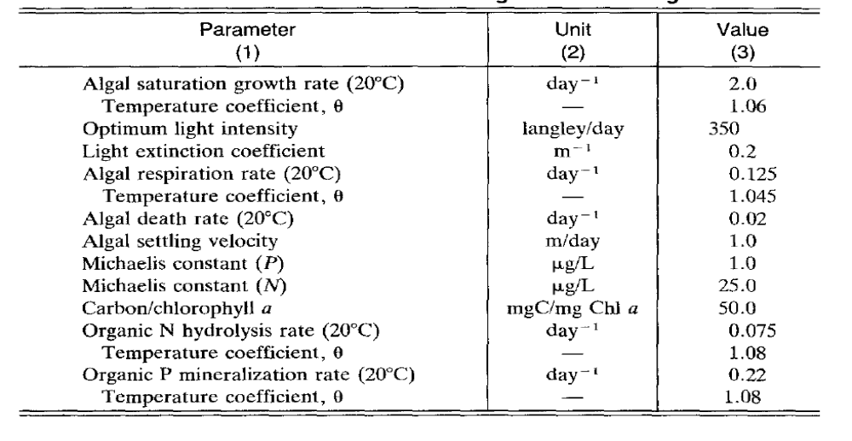

Discussions
1. Effects of initial conditions on model results:
The effects of initial concentrations in all the 4 segments are investigated. The following situations of 10 times NH₃, 10 times PO₄³⁻, 10 times NH₃ and PO₄³⁻, and 100 times NH₃ are tried, respectively. Under most of the situations, the concentrations of chlorophyll a and dissolved oxygen in all the segments do not present observable changes. When 100 times NH₃ concentration is applied, there is not a change happening to the chlorophyll a, i.e. raising initial nutrients concentration does not lead to significant algal growth. However, it is noticed that the dissolved oxygen has a notable decreasing. Generally, the variations of initial condition do not have a notable effect on eutrophication. Actually, initial conditions just affect the time to get steady state, that is, the higher the initial concentration is, the longer it takes to maintain steady state.
2. Effect of segment 3 boundary conditions
After changing the parameters of segment 3 boundary conditions, there is not notable change in the modeling result. The reason should be that there is no input from the Prince William Sound entering segment 3, therefore, the concentration in its boundary does not influence its state.
3. Effect of freshwater inflow dominating
The potential of eutrophication under the freshwater inflow dominating situation is assessed. In the table below, the comparison of the initial freshwater inflow (100 cfs) and the intensified freshwater inflow (100000 cfs) is presented based on the calculation results in the *. edf file.
Table.6. Freshwater Inflow Dominating Eutrophication Potential
Initial Freshwater Flow---100 cfs
Segment # | CBOD₅  Mg/L | TKN  Mg/L | NH₃  Mg/L | NO₂/NO₃  Mg/L | TP  Mg/L | PO₄ ³⁻  Mg/L | Chlo a  µg/L | DO  Mg/L
1 | 0.509 | 0.587 | 0.481 | 0.051 | 0.211 | 0.172 | 0.097 | 8.598
2 | 0.505 | 0.327 | 0.254 | 0.040 | 0.194 | 0.155 | 0.019 | 8.583
3 | 0.525 | 0.350 | 0.273 | 0.040 | 0.195 | 0.155 | 0.024 | 8.626
4 | 0.593 | 0.291 | 0.217 | 0.032 | 0.191 | 0.142 | 0.007 | 8.699
Freshwater Inflow Dominating---100000 cfs
1 | 0.995 | 3.388 | 2.879 | 0.100 | 0.390 | 0.289 | 0.991 | 9.190
2 | 0.602 | 1.082 | 0.915 | 0.096 | 0.245 | 0.196 | 0.222 | 8.502
3 | 0.978 | 3.291 | 2.797 | 0.101 | 0.384 | 0.286 | 0.956 | 9.154
4 | 0.642 | 0.733 | 0.606 | 0.072 | 0.221 | 0.167 | 0.112 | 8.607
It can be seen from table.6, that after freshwater inflow becomes dominating, all the value of the eight systems sharply rise. The phytoplankton concentration is worth the most attention. All the algal concentrations under 100000 cfs freshwater flow is less than 1µg/L. The actual maximum phytoplankton concentration is slightly over 2µg/L right after the fertilizer application (Printchard et al. 1989). This level is considered insignificant from the perspective of eutrophiation. However, it is analyzed that without strong tides, the time spent on mixing is longer.
4. Model sensitivity analysis of loads:
Algal growth is subject to nutrient available. Nutrients, such as nitrogen (mainly NH₃) and phosphorous (mainly PO₄³⁻) are the principle resources for algal growth. According to the research by McCutcheon (1990), 7.0 kg/day of NH₃ and 0.7 kg/day of PO₄³⁻ are incorporated into the input data file. The idea here for model sensitivity analysis of loads is to assess the potential of phytoplankton biomass growth with the variations of fertilizer nutrients loading rates. 1, 10, 100 and 1000 times of loading rates are investigated by varying the conversion factor of loads. The main purpose of applying extremely high load, which is hardly possible in reality, is that if the extreme condition does not significantly bring forth eutrophication, then other lower loads will not cause this problem. First, the effects of loading rates are investigated by using the light extinction coefficient of Norwalk. The results show very little change. This may be due to the high light extinction coefficient which makes light become the limiting factor of algal growth. Then, the values of light extinction coefficient are modified to smaller 0.2. The results are shown in table.7. It can be discovered that when the increasing load applied helps algae to grow. However, under the experiment condition, the growth is insignificant. From the standpoint of eutrophication, fertilizers application is not posing a threat.
Table.7. Effects of Loading Rates of Nutrients in Snug Harbor
Segment # | 1 | 2 | 3 | 4
0 time load  µg/L | 0.367 | 0.115 | 0.264 | 0.044
1 time load  µg/L | 0.367 | 0.115 | 0.265 | 0.044
10 times load  µg/L | 0.369 | 0.116 | 0.268 | 0.045
100 times load  µg/L | 0.389 | 0.123 | 0.295 | 0.049
1000 times load  µg/L | 0.432 | 0.141 | 0.360 | 0.058
5. Ammonia Toxicity
It is known that when high concentration of fertilizer is applied, ammonia has significant concentration. With the nutrients loading rate being 1000 times of the initial one (under high fertilizer application), the model is runned. The simulation is under 12.4 °C and pH 7.5 conditions. The results gained are listed in the following table. The amount of un-ionized NH₃ in each segment is calculated. All the un-ionized NH₃ concentrations in the 4 segments exceed the un-ionized NH₃ criterion 0.02 mg/L. It can be noticed that with the increasing of fertilizer application, the amount of ammonia shows significantly exponential rising. By running EUTRO model, it can be expected that when the loads is around 600 times loads, the criterion of 0.02 mg/L can be matched.
Table.8. Ammonia Toxicity Assessment under 1000 times loads
Segment # | 1 | 2 | 3 | 4
1000 times load NH₃ (mg/L) | 3.438 | 0.827 | 1.642 | 0.420
un-ionized NH₃ (mg/L) | 0.0258 | 0.0062 | 0.0123 | 0.0032
6. Effect of tides
Tides play a very important role in the flushing and transporting of the nutrients. It is reported that the maximum tidal fluctuation reaches 4.57 m. Strong tides help the circulation and exchange of nutrients mass between the embayment and the Prince William Sound. The 100 cfs freshwater inflow is evenly divided into two parts. The advective flows decrease by one. Therefore, there are certain changes in the input data file data group D, flows. The region of interest is shown below:
1 5 + * + * + * + * + * D: FLOWS
2 1.00000 0.0283
3
1.0 0 1 1.0 1 3 1.0 3 0
2
50.0 0. 50.0 365.
4
1.0 0 1 1.0 1 2 1.0 2 4 1.0 4 0
2
50.0 0. 50.0 365.

Table.9. Comparison of no tides and strong tides
Segment # | 1 | 2 | 3 | 4
Chlorophyll a (µg/L) | 0.097 | 0.019 | 0.024 | 0.007
Chlorophyll a  µg/L | 0.404 | 0.197 | 0.022 | 0.006
Employing 1 time load, the effect of tides is investigated. From table.9, it is concluded that without strong tides flushing the estuary, the nutrients tend to stay a relatively long time in Snug Harbor. Moreover, due to small freshwater inflow into segment 1 and 3, dilution effect is insignificant. Results show that there are significant increments of phytoplankton biomass in the segment 1 and 2.

Summary and Conclusions
The mass transport using salinity data is calibrated and the seasonal algal concentrations are simulated to study the potential of eutrophication in Snug Harbor. The WASP/EUTRO modeling framework is applied. The mass transport of the system is calibrated and model sensitivity analysis is conducted. The effects of initial conditions, tides, freshwater inflow and boundary conditions are evaluated. Based on this, a series of nutrient loading rates of different fertilizer and ammonia toxicity are further studied to evaluate the impacts of bioremediation. Model results and the available data indicate that because of the rapid tidal exchange between the embayment and the Prince William Sound, the algal growth is limited. Therefore, it is believed that there is insignificant algal biomass, i.e. no risk of eutrophication in Snug Harbor after bioremediation nutrients application. Certain ammonia toxicity is expected, especially at high application loading rates.

References
Lung, W.S., Martin, J.M., and McCutcheon, S.C., 1993. “Eutrophication Analysis of Embayments in Prince William Sound Alaska.” Jour. Env. Eng., 119(5): 811-824.
Lung, W.S., and O’ Connor, D. J. 1984. “Two-dimensional mass transport in estuaries.” J. Hydr. Engrg., ASCE, 110 (10), 1340-1357.
Lung, W.S.1986. “Advective acceleration and mass transport in estuaries.” J. Hydr. Engrg., ASCE, 112 (9), 874-878

